PHASE 1

BRAINSTORMING & IDEATION
PROJECT TITLE : IMPLEMENT CLIENT SCRIPT & UI POLICY (INCIDENT)

Submitted By

Name: K. Yamuna

Department: B.Sc Computer Science

College: Government Arts and Science College for Women, Paramakudi

College code: AU64

Platform : ServiceNow

- INTRODUCTION

- ServiceNow is a cloud-based platform used for managing IT services and business processes. Incident Management is one of the important features of ServiceNow.

- Incident records contain information about issues that need to be tracked and resolved. Accurate data entry is important for proper incident management.

- This project focuses on implementing Client Scripts and UI Policies to improve data accuracy and control field behavior in Incident records.

2. PROBLEM STATEMENT

- Incident records often require consistent and accurate data entry. However, manual data entry may result in incomplete, inconsistent, or incorrect information.

- This can affect reporting accuracy, SLA compliance, and overall service quality.

- Therefore, UI Policies and Client Scripts are required to control field visibility, mandatory status, automatic field updates, and save-time validation.

3. PROJECT OBJECTIVE

- The main objective of this project is to demonstrate how ServiceNow Client Scripts and UI Policies can be used to enforce data integrity on Incident records.

The project aims to:

1. Make fields mandatory based on conditions.
2. Automatically populate field values.
3. Control field behavior dynamically.
4. Prevent invalid record submission.
5. Improve data accuracy and consistency.

4. PROJECT SCOPE

The scope of this project includes:

- Creating UI Policies for Incident records.
- Configuring UI Policy Actions.
- Implementing onChange Client Scripts.
- Implementing onSubmit Client Scripts.
- Implementing onCellEdit Client Scripts.
- Testing conditional field behavior.
- Validating Incident record submission.

5. PROPOSED SOLUTION

- The proposed system uses ServiceNow UI Policies and Client Scripts to apply business rules directly on the Incident form.

- When the Impact field is set to High, the system applies the configured field behavior, automatically sets Urgency to High, and validates the Assigned To field before saving.

- The system also prevents direct State changes through list editing.

6. EXPECTED BENEFITS

1. Improved data integrity.
2. Reduced manual errors.
3. Better Incident Management.
4. Automatic field updates.
5. Consistent data entry.
6. Improved form validation.

7. TECHNOLOGIES USED

- ServiceNow Platform
- UI Policies
- UI Policy Actions
- Client Scripts
- JavaScript
- Incident Management

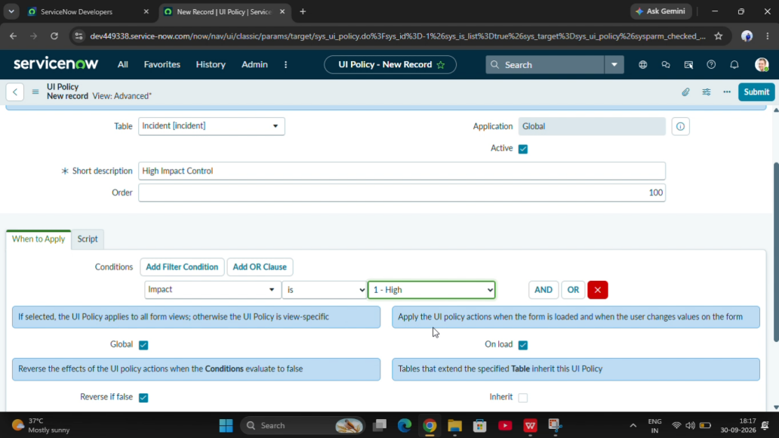

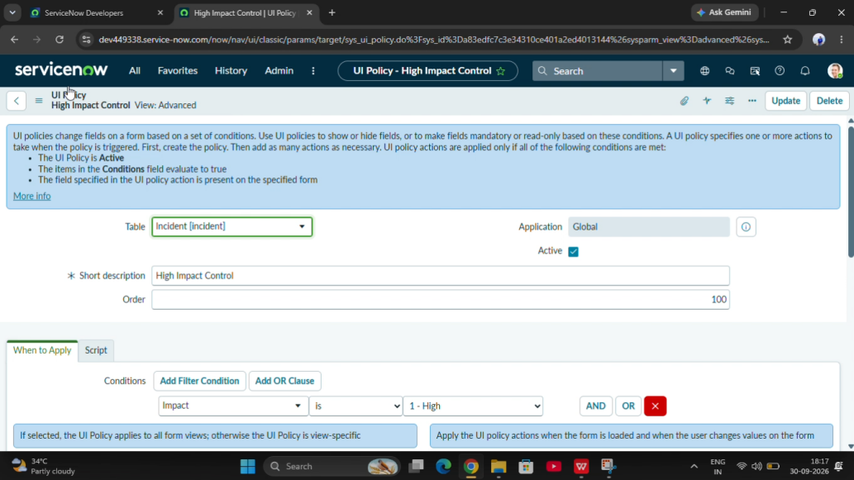

8. CONCLUSION

- This project demonstrates how UI Policies and Client Scripts can improve data accuracy and consistency in ServiceNow Incident Management.

- The proposed solution helps enforce business rules, automate field behavior, and prevent incomplete Incident submissions.PHASE 1

